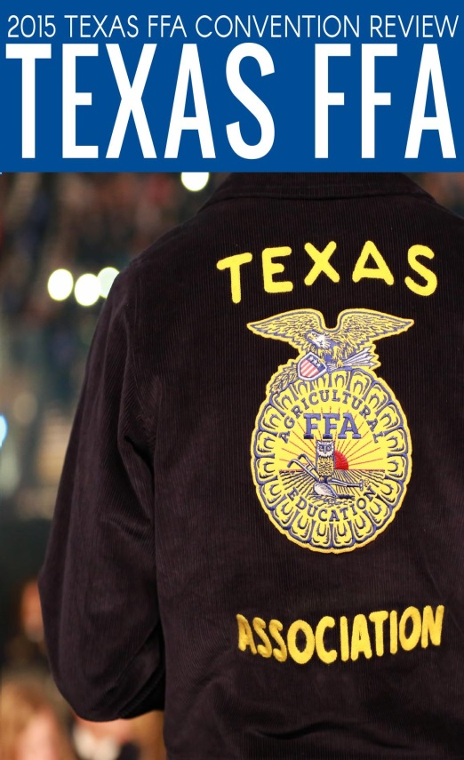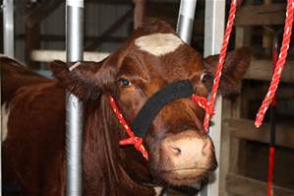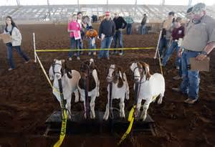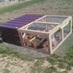

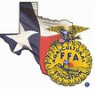
Mission
FFA makes a positive difference in the lives of students by developing their potential for premier
leadership, personal growth and career
success through agricultural education.

Rider Agricultural Science Education and the FFA program are part of a growing Texas trend - students who are looking for Leadership with a Purpose. Our country seeks for ways to connect with values that make us great. Some suggest a movement back to "the basics" the three Rs (reading, writing and arithmetic), but maybe the skills we need to empower our youth include: Respect, Responsibility and Resiliency. Our Rider agricultural education / FFA program develops students of character and empowers them with leadership skills for personal growth and career success.
We need your help. Supervised Agricultural Experience programs, or SAEs, provide students a "hands on" opportunity to learn about free enterprise, stewardship and the value of "hard work." Participation in the 2016 Wichita County Jr. Livestock Show is a chance for them to demonstrate and share their efforts through the exhibiting of their projects. Join us in telling our students [our future leaders] "we are proud of you" by making a generous- tax deductible- gift. Your contribution can be given to the Rider Ag Backers for the purpose of the 2016 Wichita County Jr. Livestock Show.
Gifts can be sent to:
Rider Ag Backers
PO Box 9244
Wichita Falls, Texas 76310

"The philosophy of the school room of one generation will become the philosophy of government in the next." - Abraham Lincoln. Thank you for your support. Together we empower future generations with Respect, Responsibility and Resiliency.
Pledge Form
Wichita County Junior Livestock Association
Donor Information
Business ___________________________________________________
Contact Name _______________________________________________
Billing Address _______________________________________________
City/State/Zip Code ___________________________________________
Telephone __________________________________________________
Fax ________________________________________________________
E-Mail ______________________________________________________

Pledge Information
Pledge Amount _______________________________________________
*You will be billed during 1Q – 2016

Acknowledgement Information
Name to be used in all acknowledgements_________________________
___ Anonymous gift

Signature _____________________________ Date ________________

